REPORT FOR: | Corporate Parenting
Date of Meeting: | 2 October 2019
Subject: | Information report – Harrow Virtual School: Headteacher’s Enrichment Report 2018/19
Key Decision: | No
Responsible Officer: | Paul Hewitt  Corporate Director People Services
Portfolio Holder: | Councillor Christine Robson  Children, Schools and Young People
Exempt: | No
Decision subject to Call-in: | No
Wards affected: | All
Enclosures: | None

Section 1 – Summary and Recommendations

This report sets out:
- An overview of the Enrichment Programmes undertaken by Harrow Virtual School for Children Looked After (CLA) and Care Leavers.

Recommendations:
The Panel is requested to note:
- The impact of the enrichment activities on pupils’ Social, Emotional and Mental Health (SEMH) development.

Reasons for Recommendations:
- To meet the holistic needs of care experienced young people in terms of their engagement and participation in learning and future aspirations.

Section 2 – Report

1. Introduction
  - Enrichment programmes have been a popular offer for schools to engage their pupils in the wider community and teach important life-skills. Harrow Virtual School has continued to offer a wide-ranging and extended enrichment programme that promotes work related learning, community participation and personal development. The last academic year 2018-2019 has seen a threefold increase in the amount of activities offered and taken up by Harrow’s Children Looked After (CLA). This report will show the impact of all of the activities on our young people, all of whom, by participating, have grown in confidence and learnt to step out of their ‘comfort zone’. Harrow Virtual School’s Enrichment programme has been supported by Sir John Lyon’s Charity and many activities have been shared with Virtual Schools in Ealing, Brent, Barnet and Hillingdon.

  - ‘MyBnk’
Target Group: Post-16 and Care leavers

Accreditation: Adult Level 1 Certificate in Personal Money Management (Skills & Education Group)

This is a two-day workshop which teaches students how to manage their money. The course covered a range of financial areas to include:
- Living independently - managing a tenancy
- Buying essentials for everyday living and prioritising spending
- Managing a bank account, internet banking, understanding debit and credit cards
- Working to a budget, savings and avoiding debts

The workshop took place from 16th to 17th July 2019 and was attended by two Harrow Care leavers. This was a combined session with care leavers from Ealing Virtual School. Throughout the session our young people had opportunities to ask questions about things they were unsure of.

The workshops were successful. The young people reported the following:
‘A very good informative course with a great trainer’

‘It would be beneficial for younger care experience children, as this would help them to think about their finances earlier’

‘Learning about different interest rates and developing good budgeting habits’

‘The most successful people spend time every month on planning use of their funds’

The added bonus of the course is that the accreditation will strengthen care leaver’s applications for housing.

1.3 Future Focus
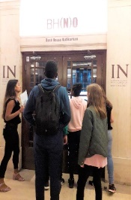
Target Group: Secondary
Programme Aims: To raise aspirations, challenge stereotypes and perceptions of academic routes not being attainable for vulnerable groups.
On Saturday 20th July 2019 a group of ten Harrow CLA students attended the Future Focus event at Kings College London. The trip was organised in partnership with Harrow Children’s Services and King’s College London in order to promote the education of care experienced young people. The activities included sessions delivered by King’s College student ambassadors.
The Programme:
- Interactive workshops about going to university and the application process
- Talks from student ambassadors about their experiences of university life and the benefits of further education
- A tour of King’s College London Campus
- Discussions on transferable skills, ‘Turning your likes into careers’
There were also two guest facilitators, one from ‘Fearless Futures’ and the other from ‘The Access Project’, who volunteered their time to run sessions on personal skills, desired qualities, future careers and pathways.
The evaluation questionnaires provided evidence that the young people enjoyed the experiences at Kings College London and were more open to the idea of university in the future. Many of the young people bonded and made close friendships during the trip. This event was an opportunity for them to build on their social skills in a semi- structured setting; their communication skills and abilities to follow instructions were also developed.
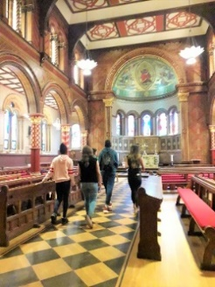
Feedback from the young people:
- It was really fun
- The day was very good
- I enjoyed learning new things
The campus tour and competition (with prize for the winner) were also popular.
The following messages were sent to the Virtual School
‘I just wanted to say thank you very much for letting ‘X be part of last Saturday's visit to King's College London. I hope all the young people were inspired by this opportunity.’ (Foster Carer)

‘The kids told me they really enjoyed Saturday’s trip, and that they made friends. They’ve been asking about future trips, and if the same group of children would be going. Great job!’ (Foster Carer)

1.4 Jamie’s Farm
Target Group: Secondary
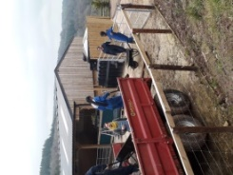
Aims:
- To promote social skills, independence, resilience and the ability to follow instructions when out of their comfort zones.
- To present students with the opportunity to experience living on a working farm
Five Harrow CLA, together with students from Barnet Virtual School, attended a residential trip to Jamie’s Farm in Monmouth, Wales, during February half-term.

We wanted our young people to develop their resilience, confidence, team-working and independent life skills, as well as to learn about the environment, caring for animals and growing crops.
Activities included farming, cooking, and gardening, log chopping, working with horses, playing games and exploring the country side. The group prepared and ate healthy nutritious food which was all homemade and where possible home-grown. The day started with a cooked breakfast, a hearty lunch, a tea time snack and a hot dinner.
The follow-up celebration event took place on Thursday 25th July and was attended by all five Harrow CLA. Our students met up with Jamie’s Farm staff at the Waterloo farm. This was a testimony to their positive engagement with the trip and their acknowledgement of the beneficial residential activities.
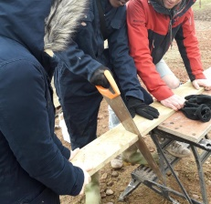
The impact of this enrichment activity was noted from the positive comments that the young people made during and after the trip. The young people made commitments to themselves to make small changes in their daily lives; these included eating more healthily, remaining active, being calm in school and asking friends for support with this, to relax, to stop procrastinating, to join a club and work hard.
Reports shared from staff at Jamie’s Farm following the residential trip outlined the qualities of each young person in addition to observations and recommendations for the schools, carers and other significant people and services to support the students. These reports were detailed and helpful in identifying further interventions such as equine-assisted therapy that was later offered to some of the young people.

1.5 Harrow School Tuition and Enrichment Programme

Target Group: Secondary
A learning based activity followed by a fun activity after school at Harrow School for Looked After Children, Harrow Young Carers and Children in Need. Sessions took place on Thursday afternoons running from 4-6pm starting since early November continuing until end of June 2019.
Sessions began in the Vaughan Library from 4pm-5pm where children made use of the reading materials and space or used the computers. Harrow School arranged for teachers and Year 12 students to tutor students. The groups requested support across the following subjects: Maths, English, Art, Religious Education, French and German.
Some of the fun activities the young people engaged in were: Sport, Cooking, Drama Cake Decorating, Visiting their observatory, A Careers Talk, Judo, Pottery and Music.
The outcomes of this programme for our students range widely from improved confidence, English language development (for students with English as a second language) , greater subject knowledge and application. Student’s social skills were also enhanced as they engaged with new young people and staff.
‘I really enjoyed older students helping me’.
‘Having different teachers from other schools made a difference’.
‘His attendance which was of serious concern before definitely improved during the weeks he attended Harrow School’s after school club.’ (SENCO)
‘His conversational English has improved so much since attending Harrow School.’ (Designated Teacher)
‘Her confidence to speak up in class is more apparent.’(Class Teacher)

1.6 StageXchange
StageXchange is a Mousetrap Theatre Project and is offered to youth groups serving disadvantaged communities and groups for young people in specific circumstances such as young carers and those in care.
Aim: To inspire young people to develop their communication, confidence and creativity through drama
Target Group: Years 6 and 7 Secondary Transition.
Theme: Starting a New School
A series of drama workshops for students in Years 6 and 7 took place in the October and February half terms. The sessions were held at the Learning Zone in Wembley Stadium. The week culminated in a performance which was attended by carers and Virtual School Staff.
As a reward for their attendance and participation on the programme, the young people were offered tickets to an England friendly match in November and March with their carers and families. Some of the young people were also invited to be mascots and flag bearers. Two children from Harrow took up this offer at both matches.
In addition to this young people also had three varied stadium tours, a goody bag, a badge and lanyard with their photo. Mousetrap also offered tickets for the young people to attend a West End shows and to attend a workshop afterwards. The young people, their carers and other children living in their households attended ‘Wicked’ and ‘Joseph and the Amazing Technicolour Dreamcoat’.
Outcomes from this two-part project were extremely encouraging:
- Enforcing positive coping strategies; the children learnt to accept the perspectives of others and the need to compromise.
- An opportunity to build on friendships; for those who attended both sessions the friendships were immediately renewed

Feedback from the Survey
83% (15/18) of surveys were completed
- 100% of participants found it easy to talk with people
- 60% participants found that they were able to cope when things have gone wrong
- 53% felt that they had increased in confidence as a result of the project
- 60% felt that they had learnt a great deal of new skills
- 73% felt that they have got to know fellow group members in a new way

1.7 Harrow Cookery School’s Baking and Cake Decorating Day
A one day baking class which took place on Thursday 11 April. The students baked a Victoria Sponge Cake, made the butter icing and buttercream and learnt intricate decorations and cake toppings.
Target Group: Primary and Secondary
Why we did it?
Our young people had expressed an interest in baking after the winter cooking sessions.
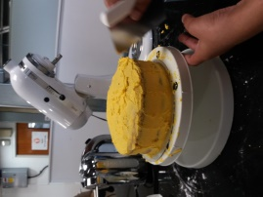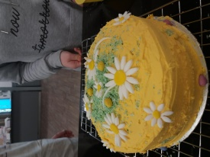

What our young people learnt?
- Kitchen health and safety
- Culinary and personal skills by following teacher modelling and working from a recipe
- Listening skills.
- Working in pairs and sharing tasks-some with those they only met that day.
- Using electrical equipment – food mixer and scales.
As a follow-up the young people suggested Bake-Off after a series of cake and dessert making workshops
Comments from carers:
‘I would certainly recommend this experience to other carers as the experience the children come away with is so satisfying and rewarding’

‘X thoroughly enjoyed herself she produced a lovely strawberry Victoria sandwich cake, and cinnamon & carrot cupcakes, just wonderful. I would highly recommend this course.’

‘The environment was also exceptional’

‘The staff were very friendly, helpful and knowledgeable.’

1.8 Harrow School Beginner Swimming Lessons
A number of our CLA have missed gaps in their education, which includes missing out on swimming lessons in their primary schools. This project provides swimming lessons to small groups of older non-swimmers. A swimming instructor from Harrow School lead the sessions.
Aims:
- For students to become confident in the water
- To learn basic swimming skills
Target Group: Secondary and Post-16
Our three students remarked that they enjoyed the lessons. The lessons will recommence this term and the Virtual School will continue to monitor their progress.

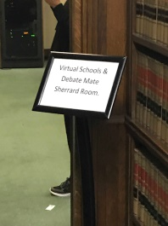
1.9 DebateMate
DebateMate focusses on talking skills, on how to present and structure an argument and how to structure a debate with other young people.

Aims: For young people to be able to present themselves well, to be able to talk in public and to present their ideas in a convincing way.
Target Group: Upper Secondary and Post-16
Four young people attended on 19th January 2019.This took place in Middle Temple, the ancient law courts right in the centre of London. It was held in Sherrard Room in the Rutledge Suite. The young people were informed of the significance of the location as it is the room where barristers are taught to present their arguments in court. As a result of this activity the pupils demonstrated increased confidence in speaking publicly and did so at the Exscitec activity (see below). They expressed that they would like to take part in this again.

1.10 Exscitec’s Brunel University Discovery Summer School 2019

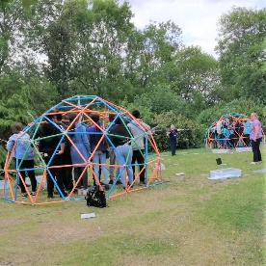
Exscitec is a provider of Science, Technology, Engineering and Mathematics (STEM) activities for students of all ages. Their programmes are bespoke and provide practical, problem-solving experiences for young people.
Target Group: Key Stage 4; Girls were particularly encouraged to attend.
Aims
To:
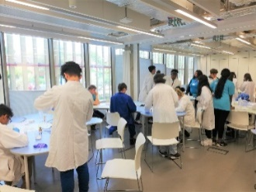
- Raise aspirations regarding pursuing Higher Education.
- Motivate students to pursue science subjects post GCSE
- Develop teambuilding , leadership and communication skills
- To experience STEM subjects through a series of fun problem solving activities.
- Verbal feedback was collated at the end of the camp and all the young people participated with this. They said it was fun, engaging and interesting. Please see their feedback wall below.

‘I now understand STEM in a much deeper level’

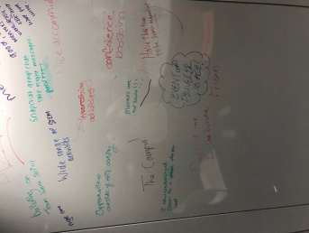
Confidence boosting’

‘Prepared me for the future’
‘Can I come again next year?!!’

1.11 BALANCE - Harrow Virtual School Emotional and Sensory Programme
A half-day pilot emotional regulation programme for children looked after during the Easter break. The programme was developed and delivered by Sara Dawson, Clinical Psychologist, and Michelle Tyson, Education Support Officer.

Target Group: Primary and Secondary
Aim: To introduce fun and creative ways for young people to notice and regulate their emotions

Activities focussed on making use of children’s senses i.e sight, smell, touch, taste, and hearing. The sessions included:
- Mindful eating
- Listening to different types of music sounds and noticing how this impacts on their mood,
- Experiencing different soothing and invigorating smells,
- Making mindful glitter bottles

The young people left with their own personalised sensory preference list, hand-made glitter bottles, and bellies full of pizza from the provided lunch.

Feedback from the young people involved and their foster carers were very positive and so the team plan to host further Balance sessions in the future.
‘The strategies had been helpful… X is using some of the strategies introduced in the programme and her behaviour and ability to express herself were continuing to improve’(Foster Carer)

‘X’s behaviour had improved, and their relationship with one another felt much stronger’(Foster Carer)

1.12 Equine Assisted Therapy: Summer Camp at Strength in Horses, Edgware Stables
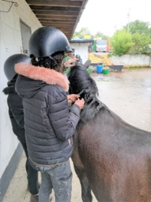
‘Strength and Learning Through Horses’ is a charity partnership operating from specialist stables which exclusively serve vulnerable or disadvantaged young people and adults. All their work focuses on empowering people to make positive change in their lives through building relationships with horses.
Target Group: Children you with social, emotional and behaviour needs. Secondary aged.
The Programme:
- Developing social skills and communication,
- Team building
- Taking on challenges i.e. getting the horses to run or jump
- Learning to self-regulate – calming strategies

Quotes from the young people who attended:
- ‘The horses were hay-some’
- ‘I really like the horses…There are these two horses that are my favourites; they are called Ruby and Rocky…They were really fun to be with’.
- ‘It was fun... They were all fun to work with’
- ‘Everything was amazing!’
- ‘I like it because it helps us to really be social, to push ourselves to do things differently and to really brighten up the day. It was a really fun activity’.
Group verbal feedback:
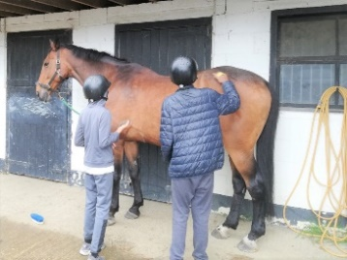
Highlights:
- Everything - even poo-picking
- Lunging
- Can’t pick
- Being with friends
- Stronger than we used to be
- Brushing the ponies
- Playing with the dog
- Cleaning the horses

New skills:
- More confidence in myself
- Understand others better
- Stronger than I thought I was
- Now able to hold a horse
- Now able to be patient
- Better at communicating, especially with horses
Possible Improvements:
- Include riding
- More brushing
- Nothing to improve
100% would like to do it again.

3. Legal Implications

3.1 There are no legal implications as this report is for information purposes.

4. Financial Implications

4.1 The Virtual School and associated activities in 2018-19 was funded from a combination of council general fund budget of £122k and the Children Looked After Pupil Premium Grant of £368k.

5. Equalities implications / Public Sector Equality Duty

5.1 The weak performance of particular underachieving groups is a concern and the Local Authority through the Harrow School Improvement Partnership has established a ‘Closing the Gap’ strategy to ensure that all groups achieve in line with the high standards of achievement in Harrow. The strategy is focussed on supporting and challenging individual schools to improve the quality of their provision, so that all groups achieve well against their peers.

6. Council Priorities

6.1 This report provides information on the performance of underachieving groups, and as such is focused on making a difference for the vulnerable. Educational performance and standards are critical in making a difference to the life chances and aspirations of families and communities. A well-educated and skilled workforce secured through quality educational provision in Harrow, contributes significantly to local businesses and industry, within and beyond Harrow.

Section 3 - Statutory Officer Clearance

Name: Jo Frost |  |  | On behalf of Chief Financial Officer
Date: 20th September 2019

Ward Councillors notified: | NO, this is an information report only
EqIA carried out:  EqIA cleared by: | NO  N/A information report only

Section 4 - Contact Details and Background Papers

Contact:

Mellina Williamson-Taylor | Harrow Virtual School for CLA, PLAC and Care Leavers.  Mellina.williamson-taylor@harrow.gov.uk  020 8416 8852

Background Papers: None

Call-In Waived by the Chairman of Overview and Scrutiny Committee |  | YES/ NO / NOT APPLICABLE*

